* Git ? git hub?
* Before version control ? issues ?
* Type of version control
* Short history of git
* Features of git
  + Speed
  + Simple design
  + Support for non-linear development
  + Distributed
  + Scalable
* Git Basics
  + Differnt than others (eg Subversion or Perforce) Snapshots Not Differences

Requirement for achieving this

* + - Nearly Eveything is Local
    - Git Has Integrity
    - Git Generally Only Adds Data(simple folder ,simple file)
    - The Three States

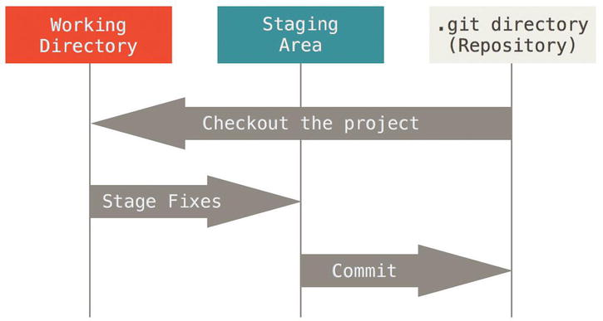

* The Command Line (Cli vs GUI)
* Installing Git
* First-Time Git Setup
* Configuration :Identity
* git config --global # User (global) -> ~/.gitconfig
* git config --system # System -> /etc/gitconfig
* git config  # Project -> /.git/conifg
* Git Basics
* Configure and initialize a repository
* Begin and stop tracking files and stage and commit changes
* Set up Git to ignore certain files and file patterns
* Undo mistakes quickly and easily
* Browse the history of your project
* View changes between commits
* Push and pull from remote repositories

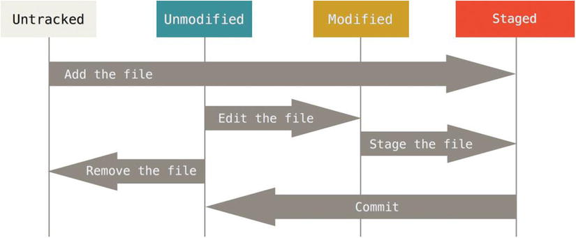

* Ignoring Files

Use .gitgnore file

Examples:

# a comment - this is ignored

*.a # no .a files

- Skipping the Staging Area

$ git commit -a -m "<msg>"

* Removing Files

$ git rm <filename> # removes file from tracking and from filesystem

* Undoing Things
  + Change the most recent Commit
    - git commit --amend
  + Untracking tracked file
    - git rm --cached <filename>
  + Unmodifying a Modified File

git restore <filename>

Unstaging staged file

git restore --staged <filenmame> # recent command

git reset HEAD <filenmame> # old command but still works so far

Restore (revert) a committed change

This will revert everything committed in a specific commit. That's why it's better to have atomic commits

git revert <commitrefs>

Deleted Files!

Deleted a file but not committed

git checkout HEAD <filename>

Deleted a file and committed

git reset --hard HEAD~1

Working with Remotes

Showing Your Remotes

git clone https://github.com/schacon/ticgit

git remote

git remote -v

Add a remote to an existing repo

git remote add [shortname] [url]

Fetching from Remote

fetches any new work that has been pushed to

that server since you cloned (or last fetched from) it**

git fetch [remote-name]

git rm --cached <file>